|  |  |
| --- | --- |
| {source code management cse2002}  LAB MANUAL | =- |

**SUBMITTED BY:**

**SRUJANA.N**

**A866175124026**

**B.TECH IN CSE(AIML) 2ND SEMESTER**

**BATCH-07**

**SI. NO. INDEX**

* + - **Basics of Linux**
    - **Introduction-Git Bash**
    - **Git Bash And Git Hub**
    - **File Creation with commit and push command**
    - **Branches Creation**
    - **Merge Request**
    - **Open and Close Pull Request**
    - **Complete Git Process**
* **EXPERIMENT-01:**
* **Basics Of Linux:**
* **1.What is Linux?**
* Linux is a family of free and open-source operating systems based on the Linux kernel. Operating systems based on Linux are known as Linux distributions or distros. Examples include Debian, Ubuntu, Fedora, CentOS, Gentoo, Arch Linux, and many others.
* **2. Linux Distributions (Distros)**
* Different versions of Linux tailored for various needs:
* Ubuntu - User-friendly, great for beginners.
* Debian - Stable and well-tested.
* Fedora - Latest features, cutting-edge.
* Arch Linux - Lightweight and customizable.
* CentOS/RHEL - Used in enterprise environments.
* **3. Linux File System Structure**
* Linux follows a hierarchical structure:
* bin → essential binary programs
* etc → configuration files
* home → user directories
* root → root user's home directory
* var variable data (logs, etc.)
* tmp → temporary files
* usr → user-installed software
* **4. Basic Linux Commands**
* **Command Description**
* Is. - List files in a directory
* Cd - Change directory
* Pwd -Print working directory
* Mkdir. Make a new directory
* Rm - Remove files/directories
* Cp. - Copy files/directories
* Mv. - Move or rename files
* Cat.- Display file content
* Sudo. - Execute a command as superuser
* man
* Show manual/help for a command
* **5. File Permissions**
* Linux controls file access with permissions.
* Use ls -l to view them (e.g., -rwxr-xr--).
* Modify with chmod, chown, or chgrp.
* **6. Package Management**
* Install/update software using package managers:
* Debian/Ubuntu: apt (e.g., sudo apt install package-name)
* Red Hat/Fedora: dnf or yum
* Arch Linux: pacman
* **7. Shell and Terminal**
* The shell interprets commands (e.g., bash, zsh).
* Terminal is where you type the commands.
* **8. Users and Permissions**
* Regular users vs. root (superuser).
* Manage users with adduser, usermod, and passwd
* **Experiment-02:**
  + - **Introduction -Git Bash**
* **What Is Git Bash?**
* Git Bash is a command-line tool for Windows that provides:
* Git command-line tools
* A Bash (Unix-style) shell
* . A way to run shell commands similar to those used in Linux/macOS
* It's especially useful for developers using Git on Windows who want a Unix-like experience.
* **Key Features:**
  + **Bash Emulation:**
* Bash (Bourne Again SHell) lets you run Linux-style commands (e.g., ls, pwd, rm).
* This makes it easier to follow tutorials written for Linux/macOS.
  + **Git Integration:**
* 다 You can run Git commands like git clone, git status, git commit directly in Git Bash.
* Useful for version control and managing code repositories.
  + **Cross-Platform Compatibility:**
* Lets Windows users interact with remote Linux servers or repositories more easily.
* How to Install Git Bash:
* Go to https://git-scm.com
* Download the installer for your OS (choose Windows).
* Run the installer and select "Git Bash" when prompted about default terminal.
* After installation, right-click anywhere and choose "Git Bash Here" to open the terminal.
* **Common Commands in Git Bash:**

**Command. Description**

Ls. List files and directories

Pwd Print current directory path

Cd. Change directory

Mkdir myfolder Create a new folder

rm filename Remove a file

git init Initialize a new Git repositor

**Command. Description**

git clone URL. Clone a repository from GitHub

git status. Show current Git status

git add. Stage all changes

git commit -m "message" Commit staged changes

* **Use Cases:**
* Managing Git repositories
* Running shell scripts
* Navigating your project with Unix-style commands
* Automating development tasks
* **Experiment-03:**
* **Git Bash And GitHub**
* **What is Git?**
* Before connecting GitHub and Git Bash, it's important to know:
* Git is a version control system to track changes in code.
* GitHub is a hosting service for Git repositories.
* • Git Bash lets you use Git on Windows with Linux-style
* commands.
* **🔗How They Work Together**
* **Here’s the typical workflow:**
* You install Git and Git Bash on your Windows
* machine.
* You create or clone a Git repository using Git Bash.
* You make changes to your files locally.
* You use Git commands in Git Bash to:

stage changes: git add

* commit changes: git commit
* push changes: git push (to GitHub)

**You use GitHub to:**

* store your code in the cloud
* collaborate with others
* view project history, pull requests, issues, etc.

**Example: Basic Workflow**

**Step-by-step using Git Bash & GitHub:**

* Clone a GitHub repo:
* Make changes to our project files.
* Stage and commit changes:
* 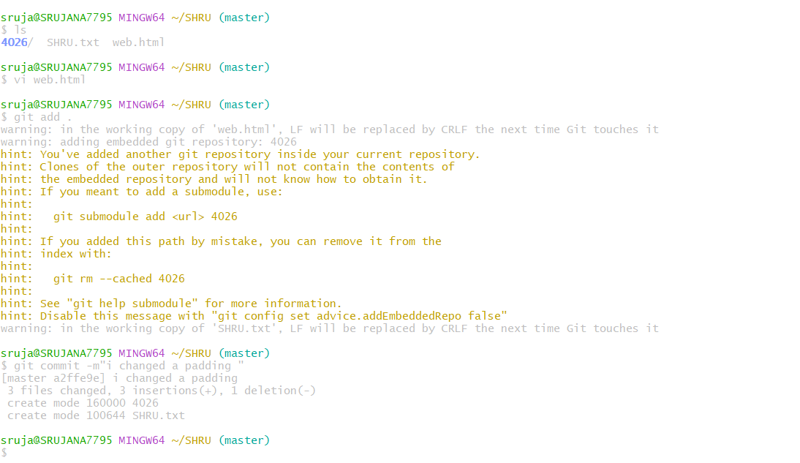

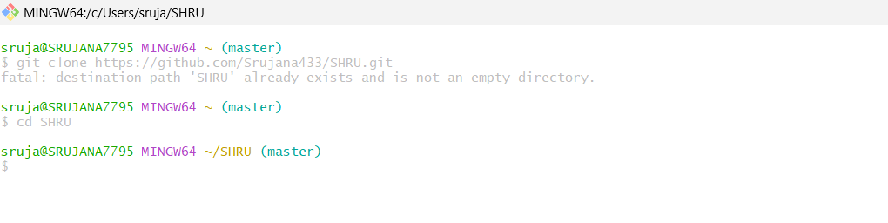

* Push changes to GitHub:
* 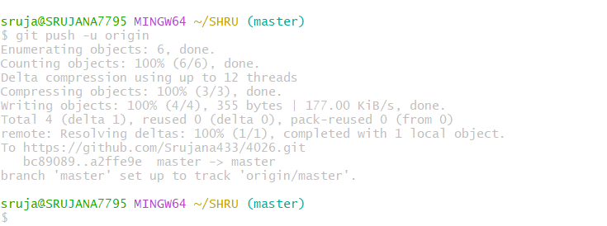

**Experiment-04:**

**File Creation With Commit And Push**

**Command.**

➢ **To Create a file,commit it and push it to a remote**

**repository using Git Bash**

**1.Create a File.**

* Open Git Bash and create a folder :
* Using cd and mkdir create a folder:

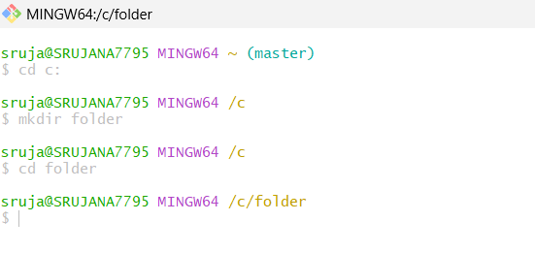

* Then git init command to create a new Git repository

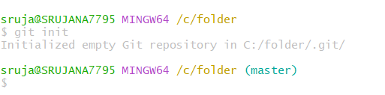

* Create a new file using vi command in Linux is used to open

and edit files using the vi editor, a powerful text editor available on most Unix-based systems:

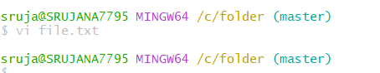

**Now open the file and write:**

Basic vi commands;

• Insert Mode:

o Press i to start editing.

• Save and Exit:

o Press ESC then type :wq to save and exit.

o Use :q! to exit without saving.

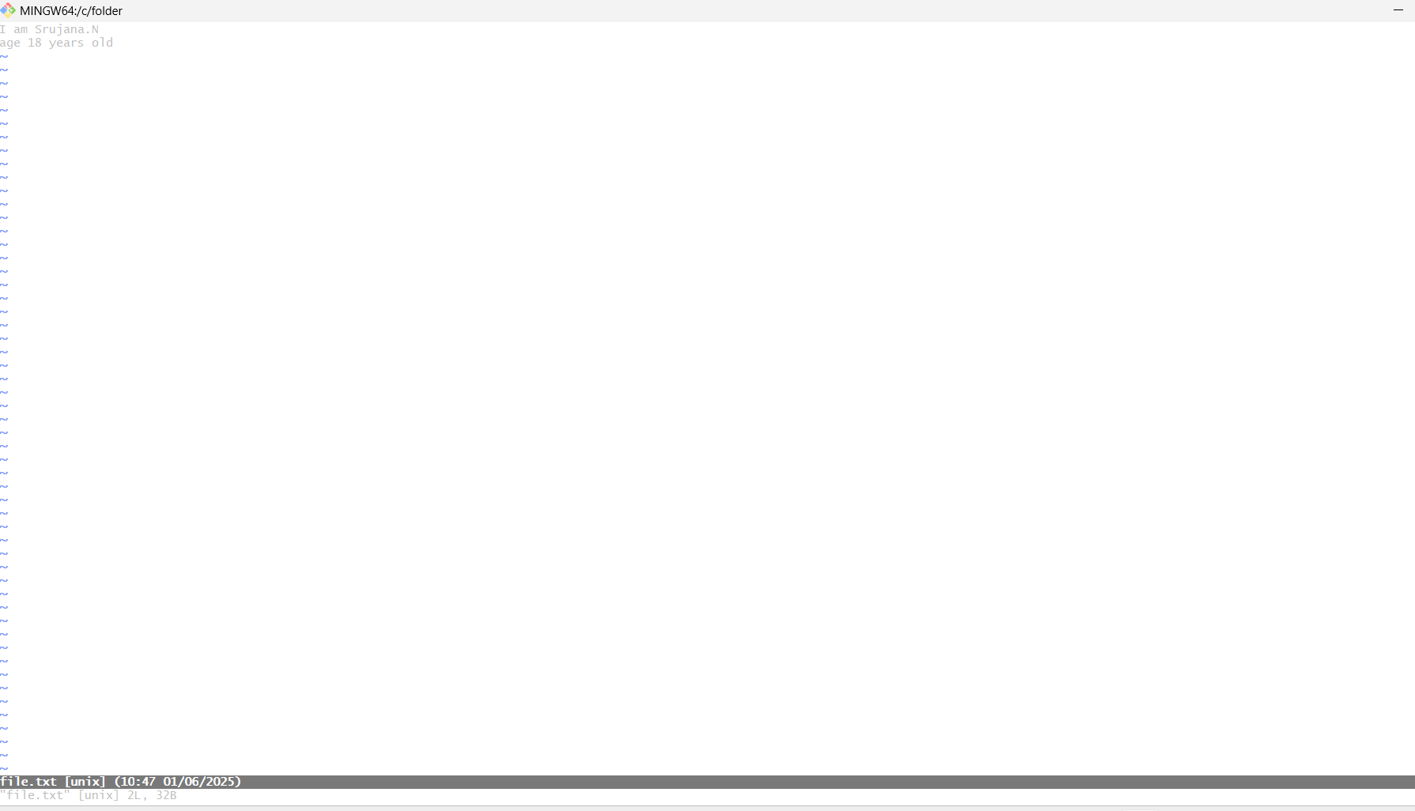

**2.Add the File to Git:**

O Stage the file for commit :

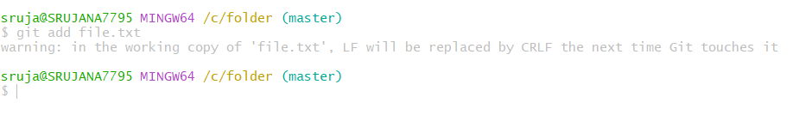

O To add all files in the directory:

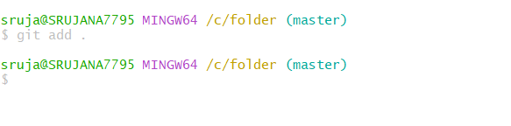

**3.Commit the File:**

O Commit the changes with a message.

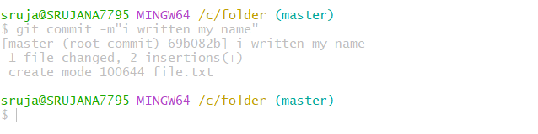

**4.Add and push to remote repository:**

Push the changes to Git Hub (assuming origin is the remote and

Main is the branch.)

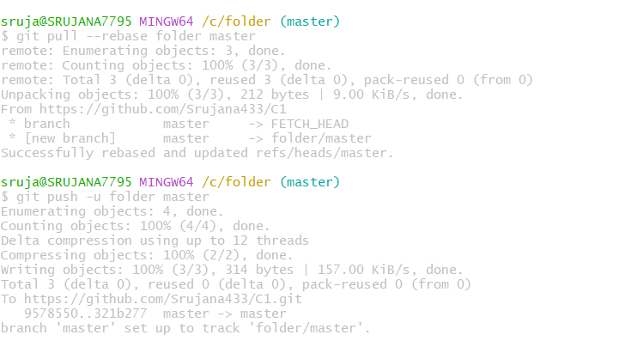

**Experiment-05:**

**Branches Creation**

In Git branches allow developers to work on different

Features or fixes without affecting the main

Codebase. Here’s how we can create and manage branches.

O **Check the branches:**

Check the branches using git branch command:

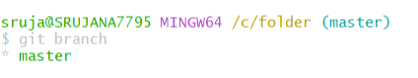

**To create new branch ;**

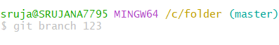

O **Switching to a Branch:**

To switch to the newly created branch:

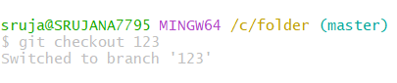

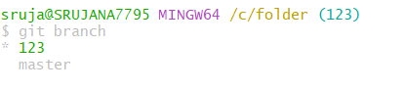

**Experiment-06:**

**Merge Request**

O A Merge Request(MR) is a feature used in Gitbased platforms like GitLab to propose and review

Changes before merging them into the main

Branch.It is similar to a Pull Request(PR) in

GitHub.

**How Merge Request Works:**

1. **Create a Branch**

A developer creates a separate branch from the main

Branch (often called main or master) to work on a specific

Feature, bug fix, or enhancement.

1. **Make Changes**

The developer writes code, commits changes to their

Branch, and pushes the branch to the remote repository.

**3.Open a Merge Request**

In the Git platform (e.g., GitLab, GitHub):

• The developer opens a merge request from their

Feature branch into the target branch (usually main).

• They add a description, possibly link related issues,

And assign reviewers.

1. **Code Review**

• Reviewers (team members or maintainers) review

The code.

• Automated checks (e.g., tests, linters) are run via

CI/CD pipelines.

• Feedback might be given; the author can make

Additional commits to address it.

**6. Merge**

The MR is merged into the target branch:

• Options include merge, squash and merge, or

Rebase and merge.

• Once merged, the feature branch can be deleted if no

Longer needed.

**Steps to Merge the Branch:**

1.Switch to the main branch (master):

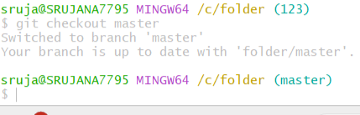

**2.Merge the branch:**

Using git mergetool and git merge main command:

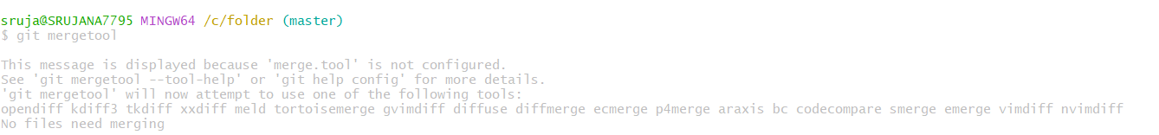

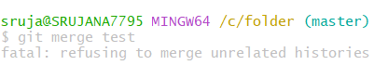

Now Press enter to edit the files and windows are opening

, then remove some red lines and add some lines:



To remove merging commit one line:

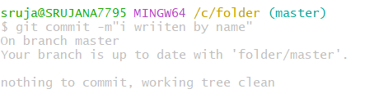

Using the command graph we can see the graph of

Commits:

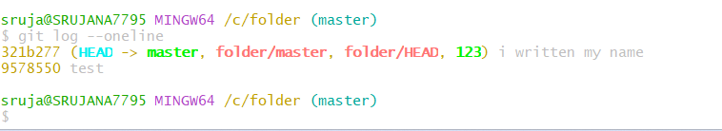

Benefits:

• Facilitates code review

• Triggers automated tests

• Maintains a clear change history

• Encourages collaborative development

**Experiment-07:**

**• Open and Close Pull Request**

**1. Open a Pull Request**

1. Push your changes to a branch on your fork or the

same repository.

2. Go to GitHub, navigate to the repository.

3. You’ll see a “Compare & pull request” button — click

it.

4. Add a title and description for your PR.

5. Click “Create pull request”.

**2. Close a Pull Request**

1. Click “Merge pull request”.
2. Confirm by clicking “Confirm merge”.
3. Optionally, delete the branch.

In the git hub account select the user which whom you

Want to merge and select the repo and fork it:

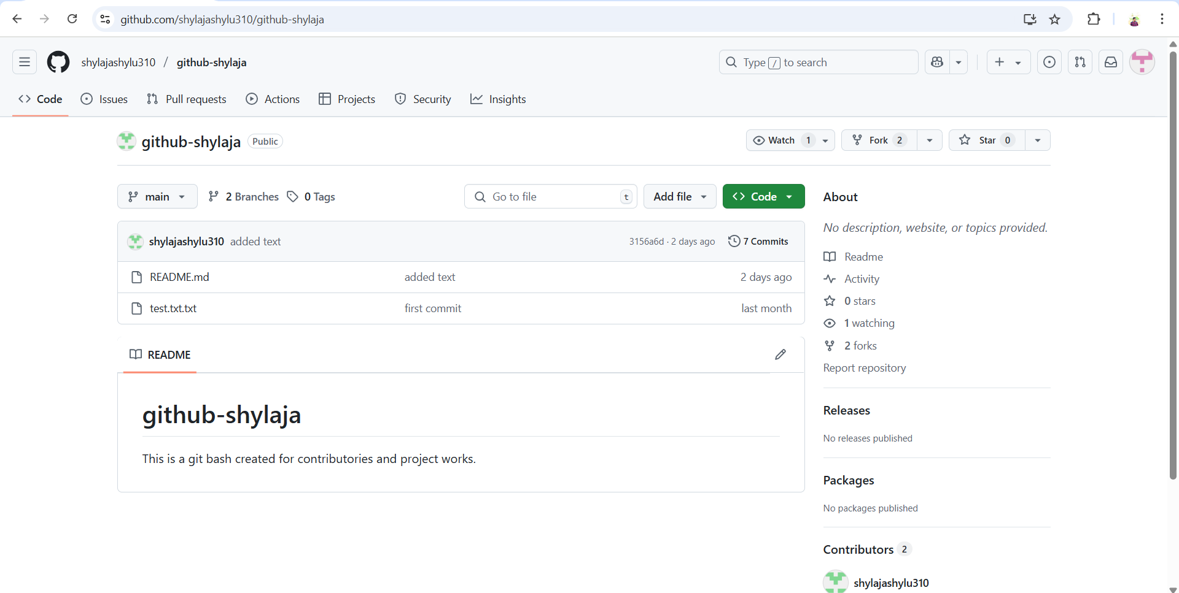

Now copy the link and using git clone command open that

File:

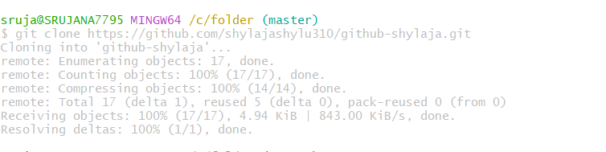

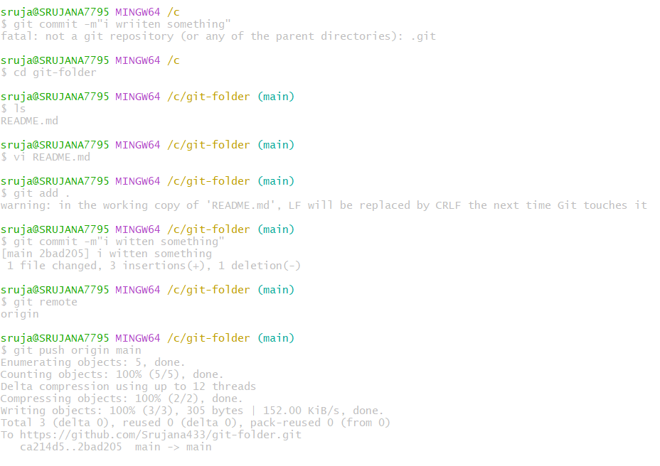

In the Git Hub account contribute to open the pull request:

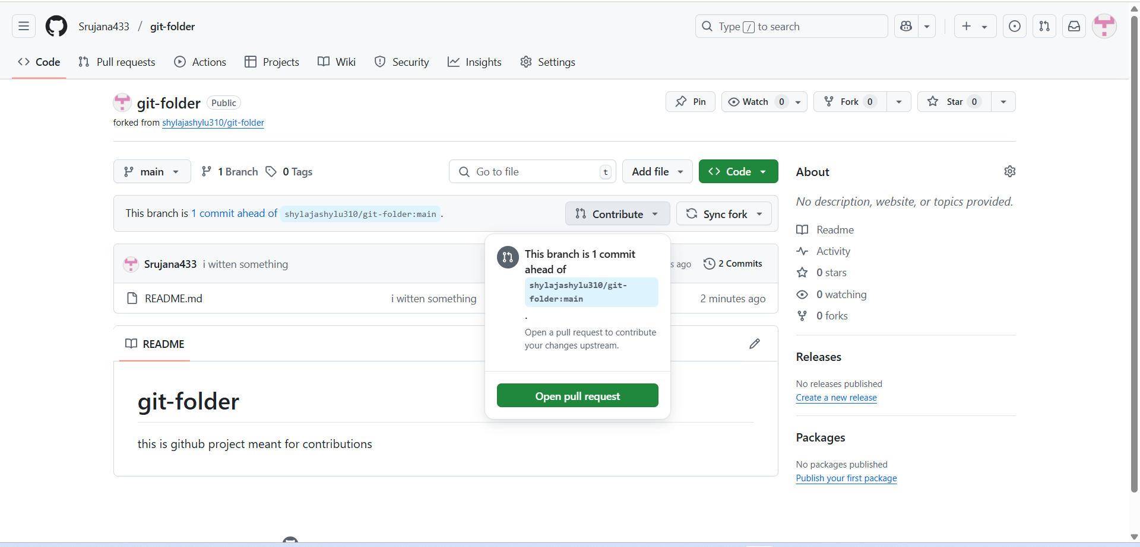

**Steps to Close a Pull Request on GitHub:**

1. Go to the repository on GitHub.
2. Click on the “Pull requests” tab
3. Find the pull request you want to close and click on

It.

1. Scroll to the bottom of the PR page.
2. Click the “Close pull request” button.

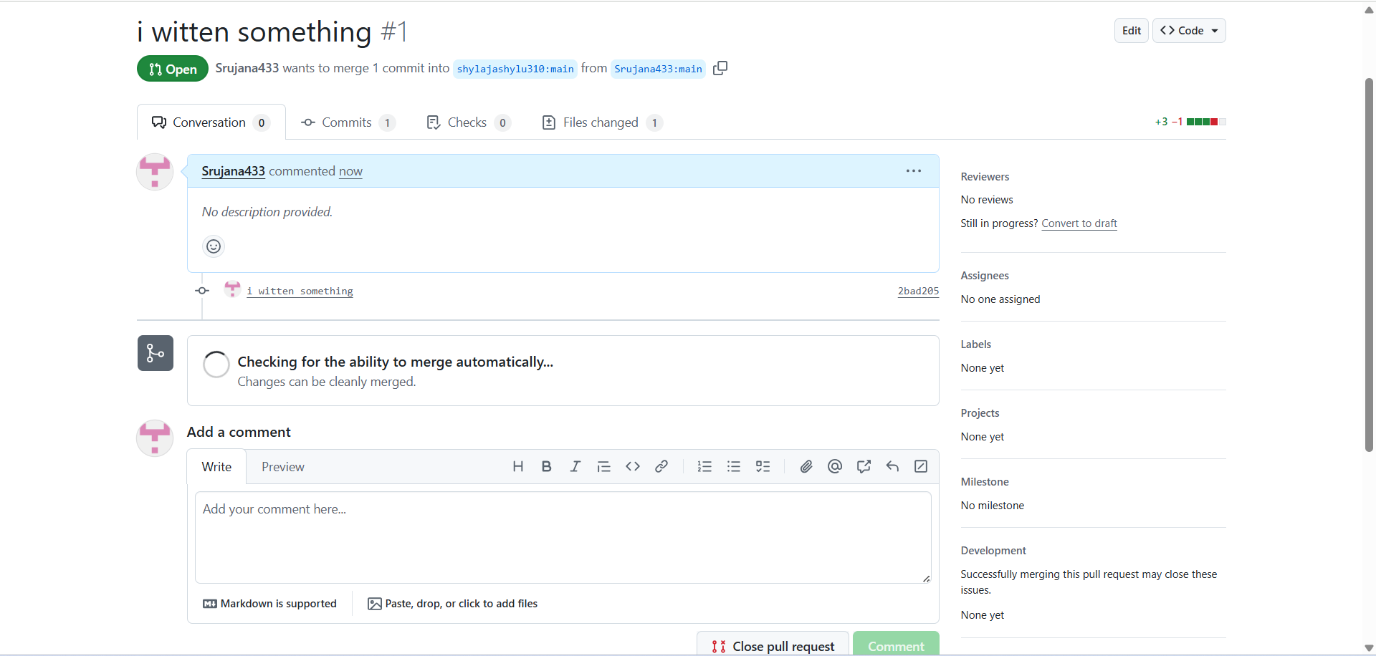

**Experiment 08:**

**• Complete Git Process.**

1. **Install Git Bash**

• Download Git for Windows from **Git’s official**

**Website.**

• Run the installer and follow the setup

instructions.

• Choose Git Bash as the default terminal option.

**2.Initialize a Repository**

• Open Git Bash and navigation to our project folder.



• Initialize a new git repository



**3.Create and Modify Files**

• Create a file using vi command:



**4.Check Repository Status**

• View changes



**6. Stage and Commit Changes**

• Add files to the staging are:

• Commit changes:



1. **Create and Manage Branches**

• Create a new branch:



• Switch to the branch:



• Merge the branch into the main branch:





1. **Git Clone:**



• Update local repository:

1. **Pull Changes from Remote Repository**



**10.Open and Close Pull Requests**

• Open a Pull Request on GitHub and merge changes.

• Close the Pull Request if needed.

